
Department of Computer Science

1900 Avenue I Huntsville, Texas (936) 294-3846
Suite 214, Academic Building One P.O. Box 2090 • 77341-2090 Fax • (936) 294-4312

COSC 6313 Homework III

Due on Monday, December 2nd, 2013

This homework weights 300 points (200 points for implementation + 100 points for class demo)

You may work individually or form a team of two members.

Option 1: Develop a neural network system that is able to recognize handwritings.

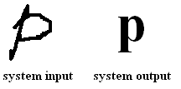

Option 2: Develop a neural network that is able to recognize a one-character text image file.

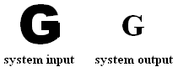

Option 3: Should you have any other project plan such as voice recognition, finger print recognition, etc. discuss with Dr. Ji.

Requirements:

- You need to pick and implement a proper algorithm that is introduced in the class for this project.
- Whichever choice your team picks, you need to have graphical user interfaces to train the neural net and to recognize the handwritings or images.
- Prepare a demonstration on the class at the due date.
- You are required to submit onto the blackboard source code, a short document (about 3-5 pages), and a complete list of Open source API modules you used in your project if any.

